**A PRELIMENERY REPORT ON**

**FACE AUTHENTICATED BILLING SYSTEM**

SUBMITTED TO THE VISHWAKARMA INSTITUTE OF INFORMATION TECHNOLOGY, PUNE

IN THE PARTIAL FULFILLMENT OF THE REQUIREMENTS

FOR THE AWARD OF THE DEGREE

OF

**BACHELOR OF TECHNOLOGY (COMPUTER SCIENCE AND ENGINEERING(AIML))**

##### SUBMITTED BY

Chinmay Kulkarni 22211289

Madhav Agrawal 22210951

Kaushik Salunke 22210126

Aditya Darak 22211578



## DEPARTMENT OF COMPUTER SCIENCE AND ENGINEERING (AIML)

**BRACT’S**

**VISHWAKARMA INSTITUTE OF INFORMATION TECHNOLOGY**

SURVEY NO. 3/4, KONDHWA (BUDRUK), PUNE – 411048, MAHARASHTRA (INDIA).

|  |  |  |  |  |  |  |
| --- | --- | --- | --- | --- | --- | --- |
| **Sr. No.** | | | | **Title of Chapter** | | **Page No.** |
| **01** | | | | **Introduction** | | 3-4 |
|  | 1.1 | | | Overview | |  |
|  | 1.2 | | | Motivation | |  |
|  | 1.3 | | | Problem Definition and Objectives | |  |
|  | 1.4 | | | Project Scope & Limitations | |  |
|  | 1.5 | | | Methodologies of Problem solving | |  |
| **02** | | | | Literature Survey | | 5 |
| **03** | | | | System Design | | 6 |
|  | | 3.1 | | System Architecture | |  |
| **04** | | | | Project Implementation | | 7-8 |
|  | | | 4.1 | Overview of Project Modules | |  |
|  | | | 4.2 | Tools and Technologies Used | |  |
|  | | | 4.3 | Algorithm Details | |  |
|  | | |  | 4.3.1 | Facial Recognition Authentication |  |
|  | | |  | 4.3.2 | Invoice Management Algorithm |  |
|  | | |  | 4.3.3 | Payment Processing Algorithm |  |
| **05** | | | | Results | | 9-11 |
|  | | | 5.1 | Outcomes | |  |
|  | | | 5.2 | Screen Shots | |  |
| **06** | | | | Conclusions | | 12-13 |
|  | | 9.1 | | Conclusions | |  |
|  | | 9.2 | | Future Work | |  |
|  | | 9.3 | | Applications | |  |
|  | | | | **Appendix C**: Plagiarism Report of project report. | |  |
|  | | | | **References**  <https://www.youtube.com/watch?v=pPkNtN8G7q8>  Thangamuthu, A. P. (2020). A survey on various online payment and billing techniques. *Humanities*, *7*(3), 86-91.  Gupta, A. (2014). E-Commerce: Role of E-Commerce in today’s business. *International Journal of Computing and Corporate Research*, *4*(1), 1-8. | |  |

# Introduction

* 1. Overview

The Face Authenticated Billing System is a cutting-edge e-commerce billing platform designed to revolutionize the way billing, invoicing, and payments are handled. By seamlessly integrating facial recognition technology for secure user authentication, the system offers an enhanced level of security, convenience, and efficiency compared to traditional billing methods.

FABS addresses common inefficiencies in existing billing systems, such as slow manual verification, susceptibility to fraud, and complex payment workflows. Using advanced facial recognition algorithms, it verifies customer identities in real-time, ensuring that transactions are conducted only by authorized individuals. This minimizes the risk of identity theft and unauthorized access.

The platform offers a comprehensive suite of features, including:

* Automated Invoice Management: Generate, send, and track invoices effortlessly.
* Secure Payment Processing: Link facial authentication directly to payment gateways for swift, secure transactions.
* User Profile Management: Maintain secure digital records with facial biometrics for returning customers.
* Multi-Device Compatibility: Accessible via mobile apps, tablets, and desktopswith synchronized data access.
* Integration with E-commerce Platforms: Easily connect with popular online stores and payment services.

The Face Authenticated Billing System is designed for businesses of all sizes, from small retailers to large enterprises, aiming to provide a seamless and secure billing experience while building customer trust. Its adoption reduces operational bottlenecks, enhances customer satisfaction, and offers a competitive edge in today’s rapidly evolving digital commerce landscape.

* 1. Motivation

With global e-commerce sales and digital payments reaching unprecedented heights, the demand for secure, efficient, and user-friendly billing systems has never been greater. As more consumers shift towards online shopping and cashless transactions, businesses are under immense pressure to modernize their billing infrastructure to meet evolving expectations.

Traditional billing methods — often reliant on manual data entry, outdated authentication processes, and fragmented payment systems — are increasingly proving inadequate. They are prone to human errors, such as incorrect billing details and misapplied payments, which can lead to customer dissatisfaction and financial discrepancies. Moreover, these conventional systems are highly vulnerable to security breaches, including identity theft, phishing attacks, and fraudulent transactions, posing serious risks to both businesses and consumers.

Another major limitation is the lack of real-time capabilities. In today’s fast-paced digital environment, customers expect instant confirmations, seamless checkouts, and immediate access to billing information. Traditional systems often fail to deliver this immediacy, leading to delays, inefficiencies, and a subpar customer experience.

As a result, businesses are actively seeking next-generation solutions that combine advanced security measures, automation, real-time processing, and user-centric designs. Innovative platforms like the Face Authenticated Billing System (FABS) are emerging as vital tools to meet these demands — offering a smarter, safer, and more streamlined billing experience for the digital age.

* 1. Problem Definition and Objectives

Problems:

* + Manual authentication and billing processes are slow and insecure.
  + Inefficient invoice management and lack of real-time updates.
  + Limited tracking and reporting capabilities

Objectives:

* + Develop a secure billing system using facial recognition.
  + Enable real-time invoice and payment management.
  + Improve user experience for both admins and operators.
  1. Project Scope and Limitations

Scope:

* + Facial recognition-based login for admins and operators.
  + Invoice generation, management, and payment processing.
  + Real-time updates, QR code generation, and email notifications.

Limitations:

* + Dependent on facial recognition accuracy and API reliability.
  + Requires internet connectivity and compatible hardware (camera).
  + Initial setup complexity for integrating APIs and configuring environment variables.
  1. Methodologies of Problem Solving
  + Requirement analysis and literature survey.
  + Modular system design (frontend, backend, authentication).
  + Agile development and iterative testing.
  + Integration of third-party APIs (Face ID, Razorpay, Firebase).
  + User feedback and continuous improvement.

# Literature Survey

* Reviewed existing billing and e-billing systems, identifying gaps in security and efficiency. Conducted a comprehensive assessment of traditional billing platforms and modern e-billing systems used across various industries. Focused on analyzing data encryption standards, user authentication protocols, and system response times. Identified vulnerabilities such as weak password policies, insecure transmission of sensitive data, and inefficiencies in invoice generation and delivery. Recommended improvements like multi-factor authentication, automated billing cycles, and real-time tracking of payments to enhance security and operational performance.
* Studied biometric authentication systems, focusing on facial recognition for secure access. Investigated the implementation of biometric technologies with an emphasis on facial recognition systems in high-security environments. Evaluated factors such as image capture accuracy, spoof detection, liveness verification, and matching algorithms. Explored use cases in banking, healthcare, and mobile applications, considering both hardware and software requirements. Also examined ethical implications, user privacy concerns, and compliance with data protection laws such as GDPR. Proposed strategies for optimizing facial recognition accuracy and minimizing false positives/negatives.
* Analyzed the integration of payment gateways and real-time notification systems in retail and e-commerce. Researched how leading retail and e-commerce platforms integrate payment gateways like Razorpay, Stripe, and PayPal to ensure seamless transaction processing. Assessed API integration methods, transaction security (e.g., tokenization and PCI DSS compliance), and multi-currency support. Also examined real-time notification systems used to confirm payments, track orders, and alert users of fraud or delays. Recommended adopting push notifications, SMS, and email alerts triggered by backend events for improved customer engagement and trust.

# System Design

* 1. System Architecture

• Frontend: React.js with Ant Design and Material-UI for responsive UI.

• Backend: Node.js with Express.js for RESTful APIs.

• Database: MongoDB for storing user, invoice, and transaction data.

• Authentication: Facial recognition via Face ID API and Firebase integration.

• Payment Gateway: Razorpay for secure online transactions.

• Real-Time Updates: WebSocket and email notifications for instant feedback.

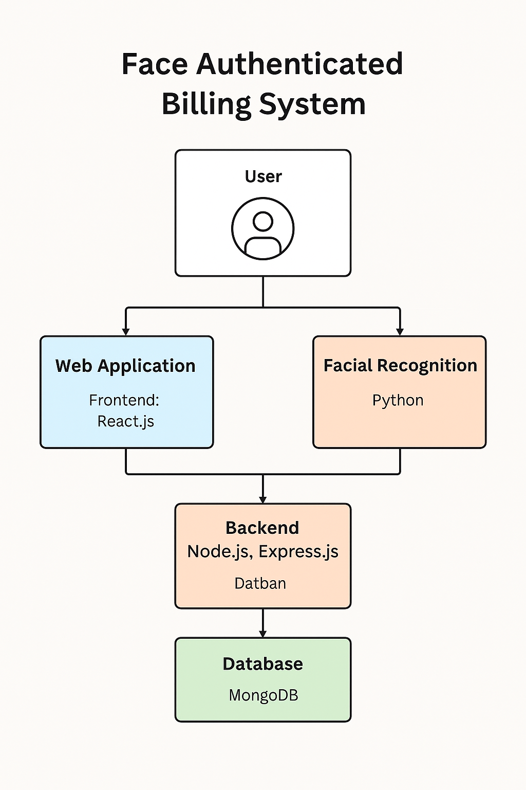

# Project Implementation

* 1. Overview of project modules
* **Authentication Module**: The system employs facial recognition login to enforce role-based access control, ensuring that users can only access features and data appropriate to their roles. By linking facial authentication with user permissions, the platform enhances security, minimizes unauthorized access, and maintains a structured hierarchy across administrative, managerial, and customer-facing operations.
* **Dashboard Module**: The system features separate dashboards for admins and operators, providing tailored interfaces based on user roles. Admin dashboards offer complete control over system settings, user management, and analytics, while operator dashboards focus on daily operations like billing, invoicing, and customer support. This separation enhances efficiency, security, and user experience.
* **Invoice Management**: The platform supports the creation, updating, deletion, and tracking of invoices with ease and precision. Users can generate detailed invoices, edit them as needed, remove obsolete records, and monitor payment statuses. This comprehensive invoice management system ensures transparency, improves cash flow tracking, and enhances overall operational efficiency for businesses.
* **Payment Processing**: The system integrates with Razorpay to enable seamless and secure payment processing. Customers can complete transactions quickly using multiple payment methods such as UPI, cards, and net banking. This integration ensures real-time payment updates, improves checkout experiences, and simplifies financial management for businesses through automated reconciliation and reporting.
* **Notification Module**: The system provides email notifications and real-time alerts for all status changes, such as invoice creation, payment confirmation, or billing updates. These instant notifications keep users informed, enhance transparency, and enable faster decision-making, ensuring that businesses and customers stay updated throughout the billing and payment process.
* **QR Code Module**: The system supports the generation and scanning of QR codes for quick access to invoices. Each invoice is linked to a unique QR code, allowing customers or operators to instantly retrieve billing details by simply scanning it. This feature streamlines operations, reduces manual search efforts, and enhances user convenience.
  1. Tools and Technologies Used
* **Frontend:** React.js, Ant Design, Bootstrap, Axios, React Webcam, QRCode.react
* **Backend:** Node.js, Express.js, Mongoose, Bcrypt.js, CORS, Dotenv, Nodemailer, Razorpay.
* **Database:** MongoDB.
* **Authentication:** Face ID API, Firebase.
* **Others:** WebSocket for real-time updates, Styled Components for UI5.
  1. Algorithm Details
     1. Facial Recognition Authentication
* Capture user image via webcam.
* Send image to Face ID API for verification.
* On successful match, generate JWT token and grant access based on role.
  + 1. Invoice Management Algorithm
* CRUD operations on invoice data.
* Real-time status updates via WebSocket.
* QR code generation for each invoice.
  + 1. Payment Processing Algorithm
* Integrate Razorpay API.
* Handle payment initiation, verification, and confirmation.
* Update invoice status post-payment and trigger email notification.

# Results

* 1. Outcomes
* Secure, role-based access through facial recognition.
* Efficient invoice and payment management.
* Real-time updates and notifications.
* User-friendly dashboards for admins and operators.
  1. Screen Shots
* Login page

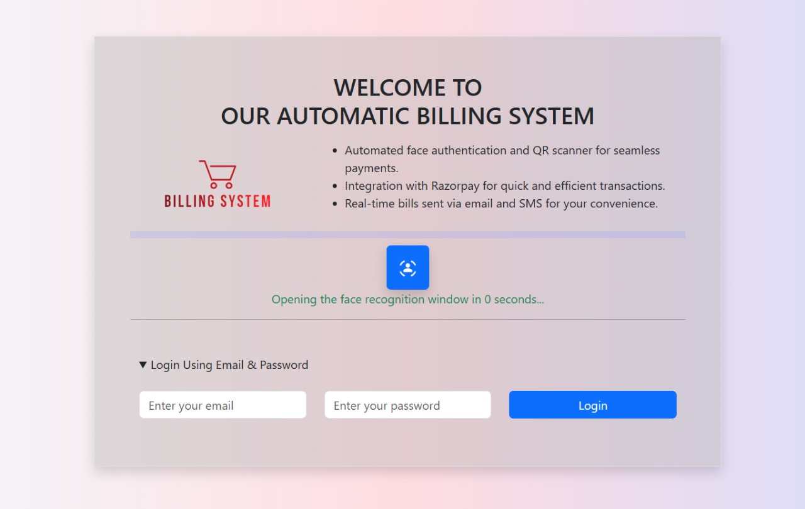

* Operator dashboard

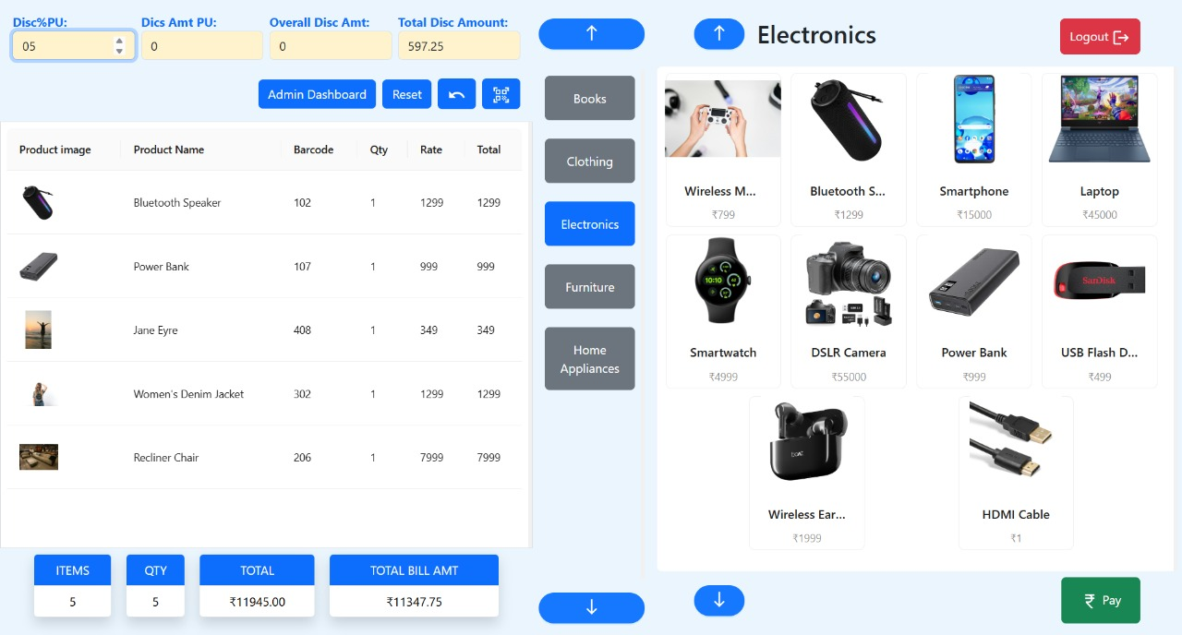

* Payment interface

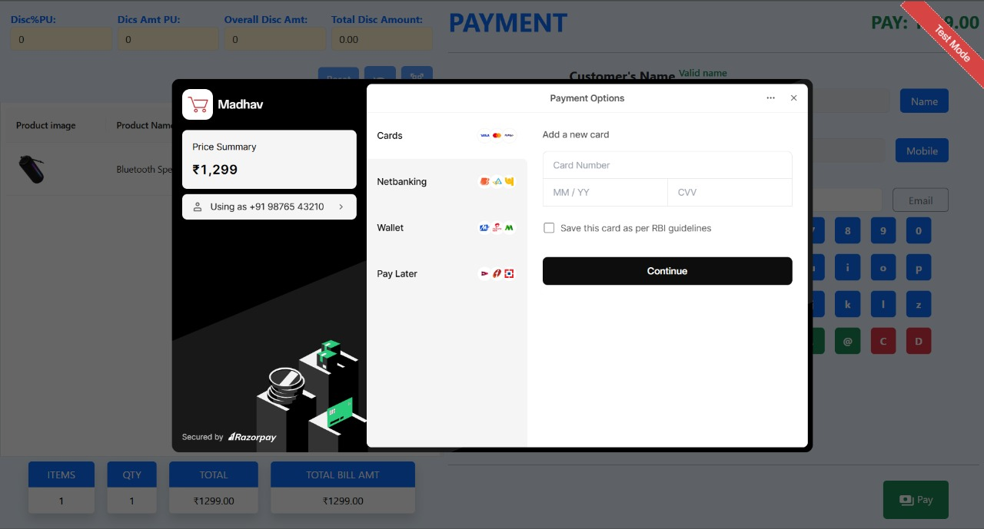

* Invoice view

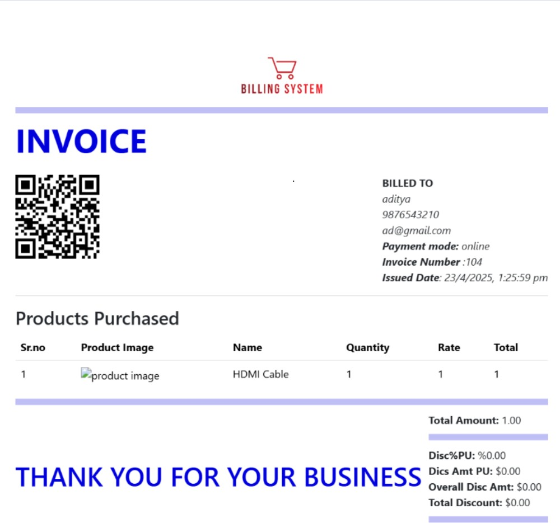

* Admin dashboard

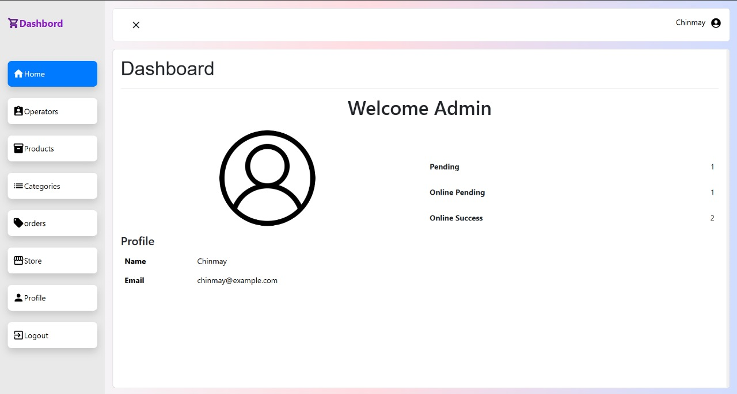

# Conclusions

* 1. Conclusions

The Face Authenticated Billing System (FABS) successfully overcomes the security vulnerabilities and operational inefficiencies associated with traditional billing systems by incorporating advanced technologies such as facial recognition, real-time updates, and integrated payment processing. By utilizing facial authentication, the system guarantees robust access control, ensuring that only authorized users can perform sensitive operations based on their assigned roles.

Additionally, real-time invoice tracking, instant status notifications, and seamless Razorpay payment integration significantly streamline billing workflows, reducing manual effort and minimizing the chances of errors or fraud. Separate dashboards for administrators and operators offer role-specific tools, promoting clarity, efficiency, and accountability within the system.

Ultimately, FABS not only enhances security and transparency but also delivers an improved user experience — providing admins with powerful management capabilities and operators with intuitive, easy-to-use tools — making it a comprehensive solution for the evolving needs of modern e-commerce and billing environments.

* 1. Future Work

The **Face Authenticated Billing System (FABS)** continues to evolve with the following key enhancements to ensure it remains a cutting-edge solution for secure and efficient billing:

* Integrate Additional Biometric Authentication (Fingerprint, Iris): To further strengthen security and provide multiple layers of authentication, FABS will incorporate fingerprint and iris recognition. This allows users to choose their preferred biometric method for authentication, improving accessibility and security for various user preferences and environments.
* Enhance Facial Recognition Accuracy with Advanced Machine Learning Models: To ensure the highest level of precision, FABS will leverage advanced machine learning models to continuously improve the accuracy of facial recognition. This includes refining algorithms to handle challenging conditions such as varying lighting, angles, and partial obstructions, ensuring faster and more reliable identification.
* Expand Reporting and Analytics Features: FABS will include an expanded suite of reporting and analytics tools, allowing businesses to gain deeper insights into transaction patterns, user behavior, and billing trends. Customizable dashboards and real-time data analysis will provide admins and operators with actionable insights, supporting better decision-making and strategic planning.
* Improve Scalability for Large-Scale Enterprise Deployment: To meet the needs of large enterprises, FABS will be optimized for scalability, capable of handling millions of transactions and user accounts simultaneously. With robust backend architecture and cloud-based solutions, the system can easily scale to accommodate growing demands, ensuring high performance and reliability in large, distributed environments.
* Address Privacy and Regulatory Compliance for Biometric Data: FABS will prioritize privacy and regulatory compliance, ensuring that biometric data is securely stored and processed in accordance with global standards such as GDPR, HIPAA, and CCPA. Advanced encryption and anonymization techniques will be implemented to protect user data, while transparent data usage policies will ensure compliance with privacy regulations.
  1. Applications

The **Face Authenticated Billing System (FABS)** is versatile and can be implemented across various industries and domains, offering robust solutions for billing and authentication:

* Retail and E-commerce Platforms: Provides secure and seamless billing, integrating with online stores to offer quick checkouts and fraud prevention via facial recognition. It ensures a smooth user experience with real-time payment processing and invoice management.
* Restaurants and Hospitality Billing: Simplifies customer billing at restaurants, hotels, and other service-based businesses, allowing staff to process payments quickly and securely. Facial authentication ensures only authorized users can access sensitive payment details, enhancing both security and operational efficiency.
* Corporate Expense Management: Streamlines the approval and processing of corporate expenses by integrating facial recognition with expense reporting systems. This reduces manual errors, enhances audit trails, and accelerates reimbursement workflows, providing a secure and automated solution for businesses.
* Any Domain Requiring Secure, Efficient, and Automated Billing: Whether it's healthcare, education, or any other sector, FABS provides a scalable solution that addresses the need for secure, automated billing with advanced authentication, enabling smooth operations, enhanced security, and better user experience across various industries.